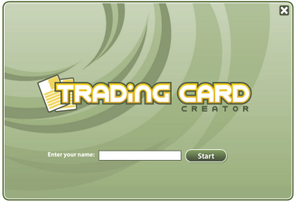
Character Trading Card Creator

Your First Name ____________________
Topic (type the character name) ____________________
Click “Fictional Person”
Source (type the name of the book) _______________________________________________________
Appearance – What does your character look like? ___________________________________________
_____________________________________________________________________________________
Personality – How does your character act? (What character traits does your person have?)
_____________________________________________________________________________________
Thoughts – What are your character’s most important thoughts?
_____________________________________________________________________________________
Feelings – What are your character’s most important feelings? _____________________________________________________________________________________
Problem – What is your character’s problem or challenge at the beginning of the story? _____________________________________________________________________________________
Goal – What does your character want to happen by the end of the story? _____________________________________________________________________________________
Outcome – Does your character succeed? What happens as a result? _____________________________________________________________________________________
Quote – What memorable things did your character say? _____________________________________________________________________________________
Action – What was the one thing that your character did that really got your attention? _____________________________________________________________________________________
Interactions – How did your character get along with other characters? _____________________________________________________________________________________
Personal Connection – Do you like your character? Why or why not? _____________________________________________________________________________________

