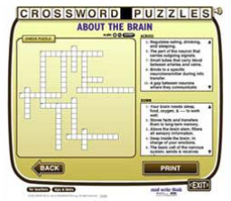
Crossword Puzzle Maker
http://www.readwritethink.org/files/resources/interactives/crossword/

First Name ______________________
Click “3-5”
Click “Create Your Own”
Title of your puzzle ______________________________________________

Enter at least 5 words and clues.
- ____________________ -- ______________________________________
_____________________________________________________________

- ____________________ -- ______________________________________
_____________________________________________________________

- ____________________ -- ______________________________________
_____________________________________________________________

- ____________________ -- ______________________________________
_____________________________________________________________

- ____________________ -- ______________________________________
_____________________________________________________________
Click “Print” and click “Print Your Work”

